Module -3

**• What is Responsive Testing?**

* **A responsive web design involves creating a flexible web page that is accessible from any device, starting from a mobile phone to a tablet.**

• **Which types of tools are available for Responsive Testing**

**Responsive testing tools: -**

1. **LT Browser**
2. **Lambda Testing**
3. **Google resizer**
4. **I am responsive**
5. **Pixel tuner**
6. **Testsigma**
7. **Screenfly**
8. **Cross browser testing**

• **What is the full form of. ipa, .apk**

**. ipa: - iPhone application**

**.apk: - android application package**

**• What is API Testing**

**Application programming interface (API) is a software interface that allows two applications to interact with each other without any user intervention.**

**• Types of API Testing**

**There are mainly 3 types of API testing**

**Open APIs: these types of APIs are publicly available to use like OAuth APIs from google. It has also not given any restriction to use them. So, they are also known as public APIs.**

**Partner APIs: - specific rights or licenses to access this type of API because they are not available to the public.**

**Internal APIs: - internal or private. These APIs are developed by companies to use in their internal systems. It helps you to enhance the productivity of your teams.**

**• What is RDBMS**

* **Its store data in the form of tables (row and columns) with most commercial relational database management systems using structure query language (SQL) to access database. An RDBMS is a type of database management system (DBMS) that stores data in a row-based table structure which connects related data elements. An RDBMS includes functions that maintain the security, accuracy, integrity and consistency of the data.**

**• What is SQL**

* **SQL (STRUCTURED QUERY LANGUAGE): - is a domain-specific language used in programming and designed for managing data held in a relational database management system (RDBMS).**

**• What is join?**

* **a join clause is used to combine rows from two or more tables, based on a related column between them.**

**• Write type of joins.**

* **Different types of SQL joins: -**
* **Inner join: - returns records that have matching values in both tables.**
* **Left (outer) join: - returns all records from the left table and the matched record from the right table.**
* **Right (outer) join: - return all records from the right table, and the matched record from left table.**
* **Full (outer) join: - returns all records when there is a match in either left or right table.**

**• How Many constraints and describes itself.**

**Constraints**

|  |  |  |
| --- | --- | --- |
| **1** | **Primary key** | **Unique + not null** |
| **2** | **Foreign key** | **It’s depending on primary table.** |
| **3** | **Unique key** | **Only unique value: blank allow** |
| **4** | **check** | **Condition you should apply.** |
| **5** | **Not null** | **Not to be blank.** |
| **6** | **Default** | **Fixed value.** |
| **7** | **index** | **When you searching some record at that time apply indexing.** |

**• Write SQL Commands**

**SQL COMMAND**

|  |  |  |  |  |
| --- | --- | --- | --- | --- |
| **DDL**  **(Data definition language)** | **DML**  **(Data manipulation language)** | **DCL**  **(data control language)** | **TCL**  **(transaction control language)** | **DQL**  **(data query language)** |
| **Create** | **Insert** | **Grant** | **Commit** | **Select** |
| **Drop** | **Update** | **Revoke** | **Rollback** |  |
| **Alter** | **Delete** |  | **Save point** |  |
| **truncate** |  |  |  |  |

**• Difference between RDBMS vs DBMS**

|  |  |  |
| --- | --- | --- |
| **Sr. no.** | **DBMS**  **(DATABASE MANAGEMENT SYSTEM)** | **RDBMS**  **(RELATIONAL DATABASE MANAGEMENT SYSTEM)** |
| **1.** | **Can use any data models, such as hierarchical, network or object-oriented).** | **uses the relational model.** |
| **2.** | **Can store data in different structures, such as hierarchical or network.** | **Stores data in tables with rows and columns.** |
| **3.** | **Can use different languages or techniques for data manipulation.** | **Uses SQL for data manipulation** |
| **4.** | **May not have the features of referential integrity.** | **Enforces referential integrity to maintain relationships between tables and ensure data consistency.** |
| **5.** | **May have limited query capabilities.** | **Has the ability to handle complex queries and join multiple tables to retrieve data.** |
| **6.** | **May have limited scalability.** | **Can handle large amounts of data and support increasing numbers of users and transactions.** |

• **How to create step for to open the developer option mode ON?**

1. **In the first step go to settings.**



1. **Now find and open about phone section.**



1. **Then tap on MIUI version several times to become a developer.**



1. **After that go back to settings and select additional settings > developer options**

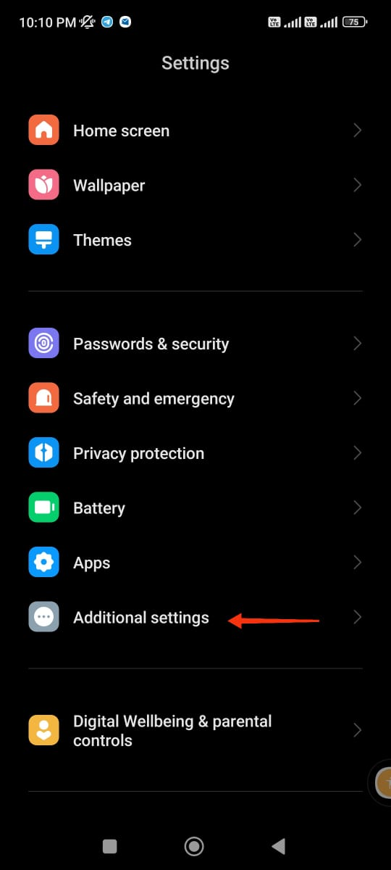

1. **perfect!**

